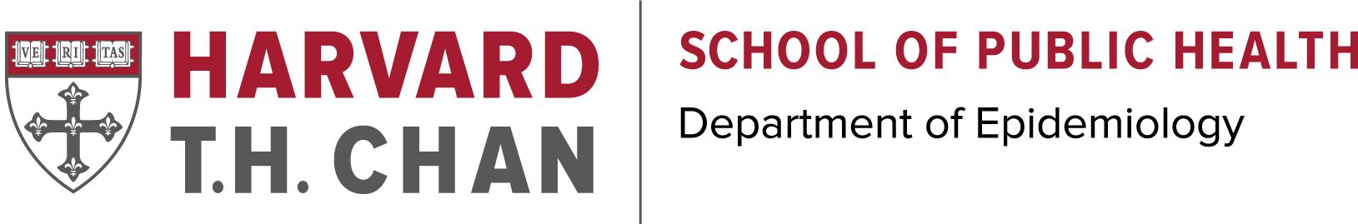
The Harvey V. Fineberg Fellowship in Cancer Prevention
2019-2020

The Harvard T.H. Chan School of Public Health’s Department of Epidemiology invites applications from doctoral students and postdoctoral fellows for the Harvey Fineberg Fellowship in Cancer Prevention.

The program’s objective is to support students and post-docs whose work is focused on cancer prevention. This work may vary from etiologic studies to behavioral or health services interventions to survivorship types of approaches to cancer prevention. Fellows will typically engage in a core set of courses that focus on cancer prevention and may also join in activities of cancer working groups that address issues of interest to the trainees. Successful applicants will have the opportunity to serve as educators and leaders by giving seminars, to attend lunches with fellow recipients as well as cancer faculty, and most importantly be a part of the Fineberg community.
Fellowship details
Eligibility: The Award is given to one or two individuals studying and researching cancer prevention per academic year. The Fellowship is not restricted to U.S. citizens, and international students are highly encouraged (non-citizen/resident), as they are not eligible for training grants. (See application document)

Award Amount: The Fellowship Award ranges from $10,000 - $20,000 per year. This award can be used to cover tuition and fees, received as a stipend, or as additional salary.

Application Deadline: April 1, 2019

Application Timeline: All materials must be received on or before April 1, 2019. The directors will review the applications and notify the recipient May 2019. The Fellowship lasts for one academic year with a start date between June 1, 2019 and September 1, 2019. Recipients are eligible to receive the Fellowship more than once, but must reapply for each year.

Contact: Eric DiGiovanni, Assistant Director of Graduate Studies
edigiova@hsph.harvard.edu

